CENG 201 - Hospital Patient Management System Report
Name: Alp Doruk Sengun
Student ID: [230444401]

Task 1: Patient List Analysis
In this first task, I created a PatientList class using a singly Linked List structure. My main goal was to manage patient records without using Java's built-in lists.
Time Complexity (Big O): I analyzed the methods in my code:
- addPatient(Patient p): This is O(n). In my code, I start from the head and loop until I find the last node to add the new one. I did not use a "tail" pointer. If I used a tail pointer, it could be O(1), but O(n) works for this assignment.
- removePatient(int id): This is also O(n). To remove a patient, I have to search the list node by node to find the correct ID.
- findPatient(int id): This is O(n) because in the worst case (if the patient is at the end), I check every node.
Linked List vs. ArrayList: The teacher asked to compare this with an ArrayList. I think Linked List is better for this hospital scenario. If I used an ArrayList, adding is easy, but removing a patient is hard. When you delete a patient from index 0 in an ArrayList, the computer has to shift all other elements to the left. This takes a lot of time (O(n)) and power. But in my Linked List, removing is very easy. I just change the next pointer of the previous node. No shifting is needed. Since a hospital is dynamic (patients come and go all the time), Linked List is the right choice for memory management.

Task 1: Patient List Analysis
Test Output:

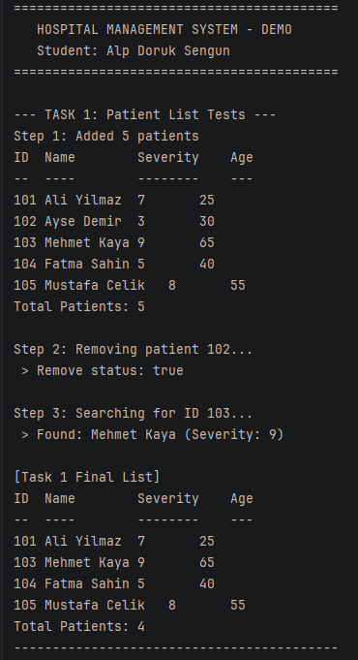

Task 2: Treatment Queue Analysis
For the treatment part, I used a Queue data structure. A Queue works on the First-In-First-Out (FIFO) logic. This means the first patient who comes to the hospital gets the treatment first.
Why did I use a Queue? It is the fairest system. In my code, I used front and rear pointers.
- When I add a patient (enqueue), I put them at the rear. This is O(1).
- When I process a patient (dequeue), I take them from the front. This is also O(1). It is very fast and efficient.
What if I used a Stack? (Queue vs. Stack) If I used a Stack (Last-In-First-Out) instead of a Queue, it would be a disaster for the hospital. In a Stack, the last person who enters gets treated first. Imagine a patient arrives at 09:00 AM. Then new patients come at 09:01, 09:02, etc. If we use a Stack, the doctors will always treat the newest patient. The poor patient who came at 09:00 AM might wait forever. This is called "starvation." Comparing complexities, both Stack and Queue are O(1) for adding and removing. But logically, a Stack is wrong for a waiting line. That is why I strictly used a Queue to ensure every patient gets treated in order.

Test Output:
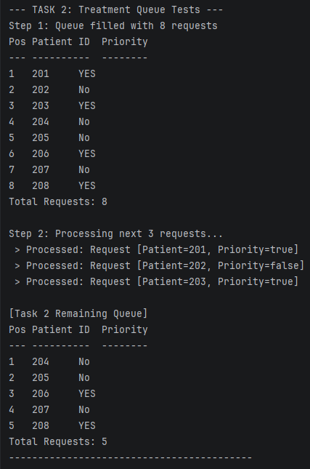
Task 3: Discharge Stack Analysis
For Task 3, I implemented a Stack to store the records of discharged patients. A Stack follows the Last-In-First-Out (LIFO) rule.
Why is a Stack suitable? I used a Stack because discharge records are like a "history log." Usually, when we look at logs, we want to see the most recent event first. For example, if I made a mistake in the last discharge, I can easily access it with peek() or pop(). In my code, push (add) and pop (remove) operations are O(1). I only update the top pointer. I don't need to loop through the list, so it is very fast.
Stack vs. Queue Comparison: If I used a Queue here, I would get the oldest discharge record first. This is not wrong, but it is less useful if I want to see what just happened. In terms of Big O performance, both Stack and Queue are the same (O(1)). The only difference is the order.
- Stack: Gives me the newest record (Good for "Undo" or "Recent History").
- Queue: Gives me the oldest record (Good for "Chronological Archive"). For this assignment, accessing the latest discharge was more logical, so I chose the Stack.

Test Output:
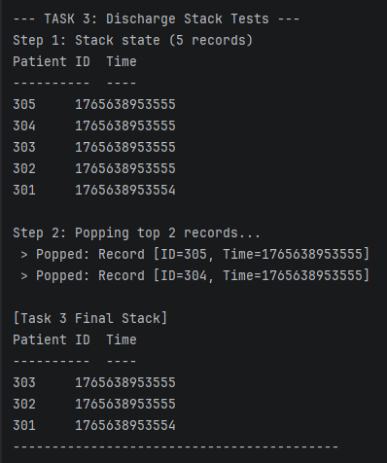

Task 4: Integrated System & Priority Analysis
In the final task, I combined the PatientList, Queue, and Stack into one HospitalSystem class. The hardest part was adding "Priority" without breaking the queue logic.
My Priority Design: The homework asked to handle priority patients (Task 4.2). I thought about checking the whole queue to find priority patients, but that would be slow (O(n)). Instead, I used a simpler and faster way: Two Queues.
- priorityQueue: For emergency patients.
- normalQueue: For normal patients.
When the processTreatment() method runs, it looks at the priorityQueue first.
- If there is someone in the priorityQueue, it treats them.
- If it is empty, then it looks at the normalQueue. This design keeps everything O(1). It is much faster than searching inside a single list.
Sorting Algorithm (Merge Sort): I also added a sorting algorithm to order patients by severity. I chose Merge Sort.
- Why? Because Merge Sort always runs in O(n log n) time. It is consistent.
- Bubble Sort: I also wrote Bubble Sort code, but it is O(n^2). If we have 1000 patients, Bubble Sort is too slow. Merge Sort is much better for large data.
Heap vs. My Queue Approach: The question asks about "Heap-based priority queue." My "Two Queues" method is O(1), which is great. But it only works for two levels (High and Normal). If the hospital had 5 different priority levels (Level 1, Level 2... Level 5), my code would need 5 queues. That is messy. In that case, a Binary Heap (Priority Queue) is better.
- A Heap can handle many priority levels.
- Adding to a Heap is O(log n).
- Removing the highest priority is O(log n). So, while my code (O(1)) is technically faster for this specific homework, a Heap (O(log n)) is the standard professional solution for complex priority systems.

Task 4: Integrated System & Priority Analysis Test Output:
